NEUR 603 Report 11: Signal Processing

Seqian Wang, In Collaboration with Sulantha Mathotaarachchi and Maxime Parent

# Part 1: Amplitude and Power Spectrum

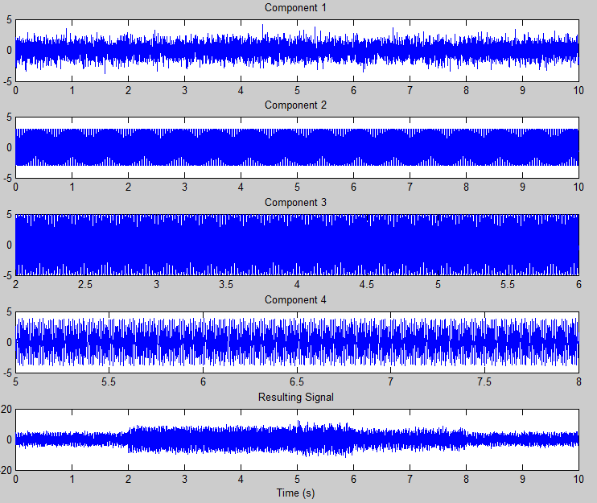

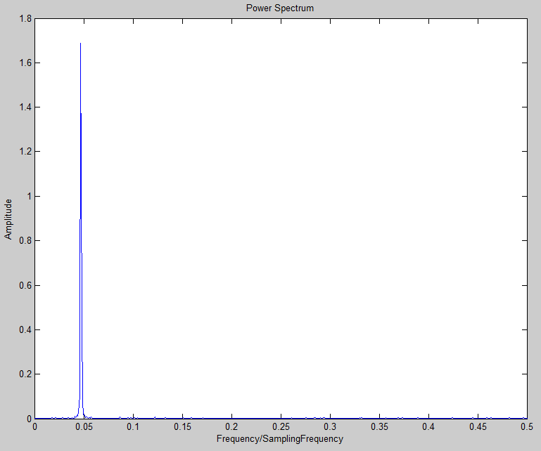Figure : Individual Signal Components and Resulting Signal

*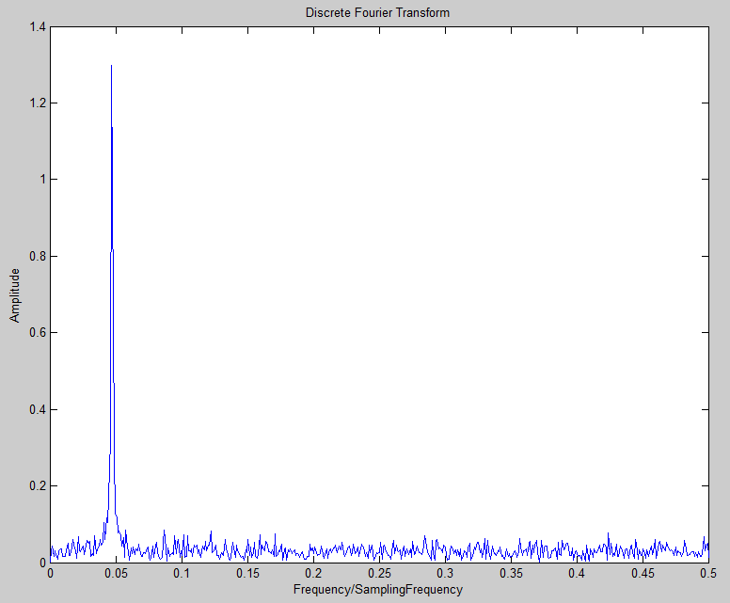Figure 2: Discrete Fourier Transform and Power Spectrum, Single-sided normalized amplitude spectrum. The figures informs on the frequency domain, or the amplitude of the signal as a function of frequency. Here, we see that low-frequency fluctuations around 0.05*1000Hz=50Hz are very strong and accounting for a big part of the resulting signal.*

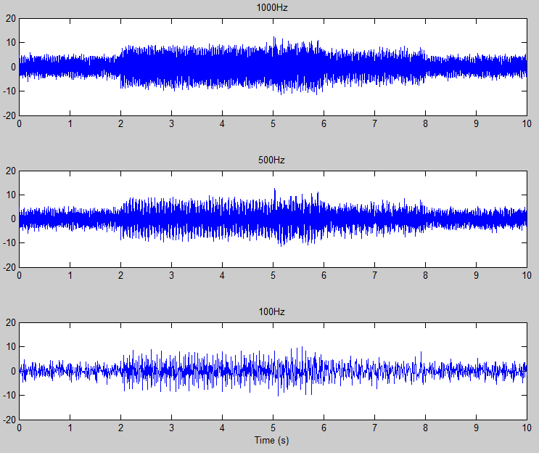

Figure : Resulting Signal at different sampling frequencies

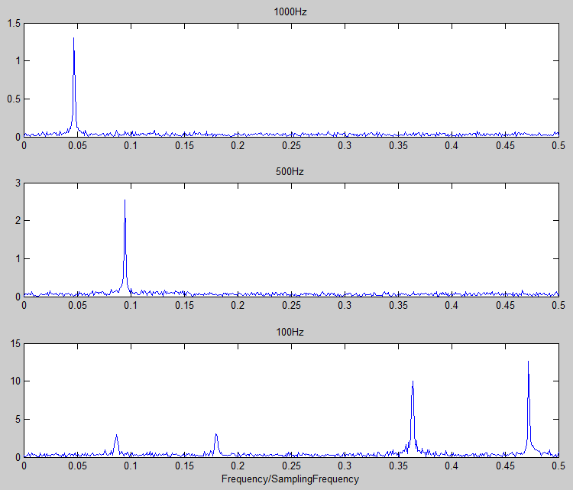

Figure : Single sided normalized amplitude spectrum at different sampling frequencies. Reducing the sampling frequency is effectively performing a low-pass filter on frequencies higher than the sample frequency. Although the strongest peak frequency appears at different locations across the figure, it is truly describing a similar frequency level (0.05/1000Hz ≈ 0.9/500Hz ≈ 0.48/100Hz ≈ 50Hz). Notice also how the amplitude increases as sampling frequency decreases, in concordance with the power law.

# Part 2: Wavelets

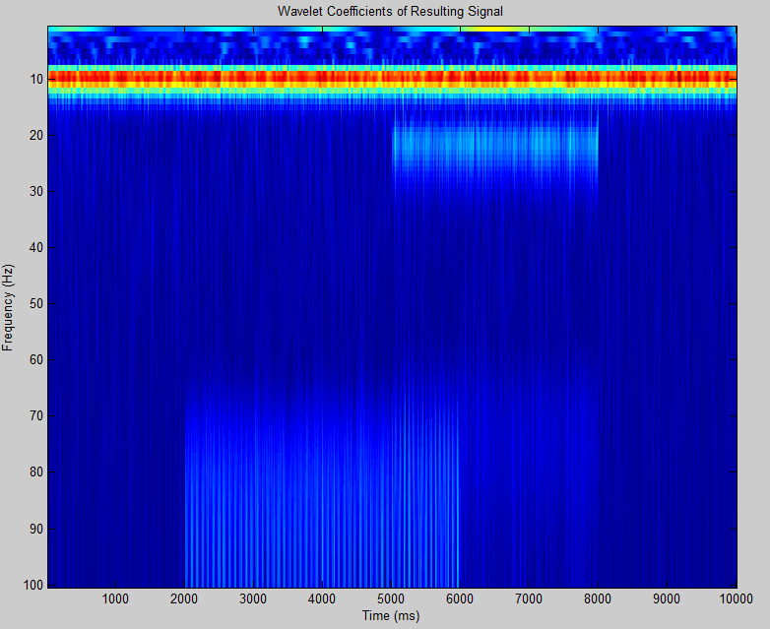

Figure : Signal Wavelet Coefficients. It is possible to see the contribution of individual components (especially 3 and 4) in their respective time range.

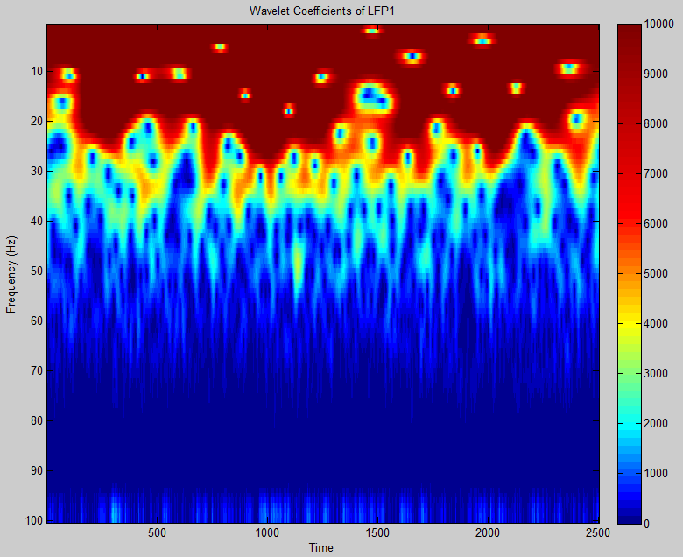

Figure : Wavelet Coefficients for Low-Frequency Potential

As power decreases with increasing frequency, we performed a db scaling to normalize power.

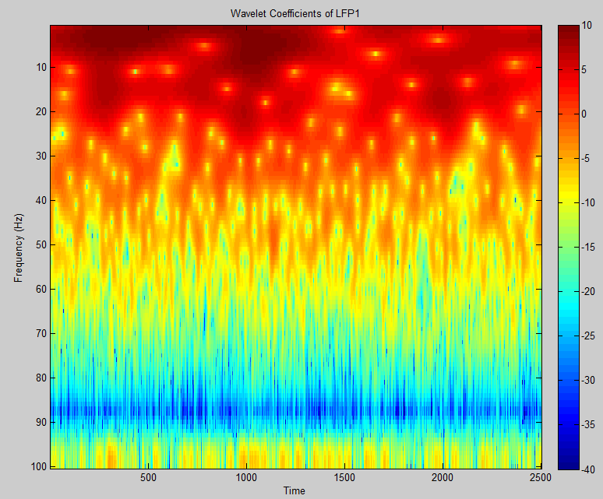

Figure : Power Values Representation of the Wavelet Coefficients for Low-Frequency Potential (-40 to 10 dB)

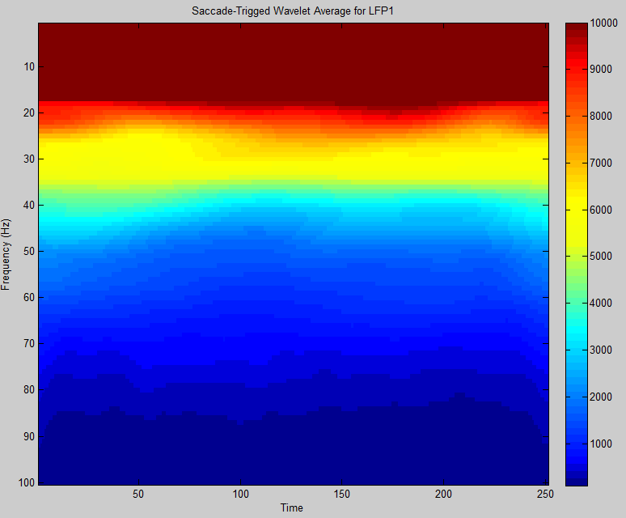

Figure : Saccade-Triggered Wavelet Average

# Part 3: Synchronicity

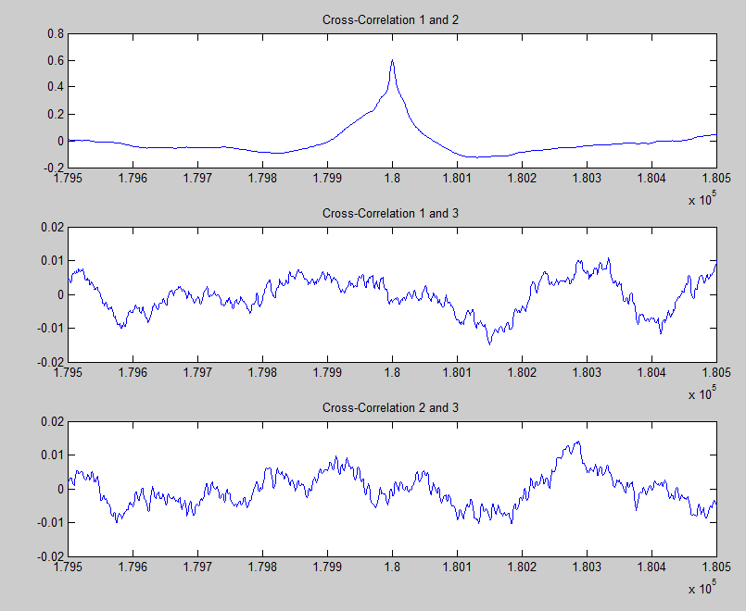

Figure : Cross-correlation between different V4 areas LFPs, with relative shifts from -1 to 1 second.

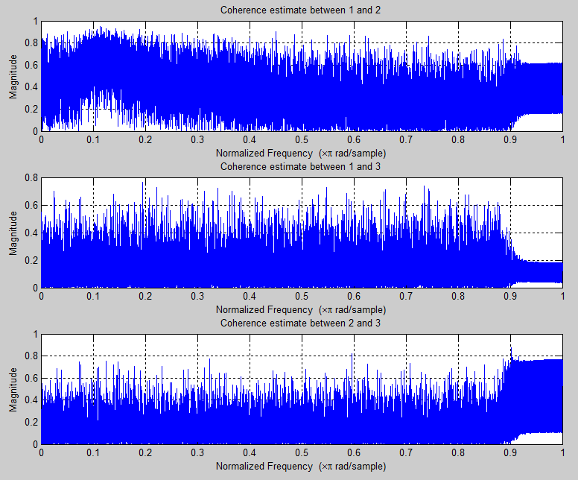

Figure : Coherence between different V4 areas LFPs across frequencies.

I did not manage to make the phase coherence work for the beta filtered signals (did not find how to calculate angle differences between signals).

Performing a Granger Causality test with a significant level of 0.05 and a max lag of 10, we find that lfp1 affects lfp2 and vice-versa. This is expected from the cross-correlation result between lfp1 and lfp2 (high similarity at 0 lag). No other significant causality was found.

Cross-correlation, coherence and Granger causality were the metrics used to assess connectivity between the various brain regions provided. The cross-correlation assess the similarity between two signals. Coherence is a function of frequency and indicate how well one signal correspond to another at each given frequency. Finally, granger causality measures whether one signal occurs before another and whether the former can predict the latter.

From the results, we find that lfp1 and lfp2 in the V4 cortex work hand in hand, having a high cross-correlation at 0 lag and significant granger causality. We also find from the coherence test that the highest correspondence is found around 0.1/500=50Hz. This suggests that lfp1 and lfp2 oscillate synchronously and that they are likely to be functionally connected. We did not see similar connectivity with other combinations.